Lab Report 4

ESE – 3014

EMBEDDED SYSTEMS COMMUNICATION PROTOCOLS AND SECURITY

Submitted to :

Linchan Wang

Submitted by:

Gurvinder Singh(748418)

**1.Simulate all operations performed in the transmitter of a PCM system include steps below. You can choose the techniques we introduced in the course, andplease show your code in text form and screenshots of each steps.**

**Solutoin:**

>>

clc;

clear all;

function signal=get_signal(frequency,axis)

signal=cos(2*pi*frequency*axis);

endfunction

%Coded Signal

dec2bin(coded_signal)

pulse_modulated_signal=interp1(n1,quantized_signal,t,"nearest");

n=7;

input_frequency=3e3;

t=[0:1/F:n/input_frequency];

input_signal=get_signal(input_frequency,t);

plot(t,input_signal);

hold on;

%Sampling of signal

sampling_frequency=44e2;

n1=[0:1/sampling_frequency:n/input_frequency];

sampled_signal=get_signal(input_frequency,n1);

stem(n1,sampled_signal,'1');

Z=legend ("Blue- Analog Signal","Red- Sampled Signal");

legend(Z, 'location', 'northeastoutside');

figure();

plot(t,input_signal,"r",t,pulse_modulated_signal,"g");

legend("input_signal","pulse_modulated_signal");

F=200e5;

dynamic_range=2;

N=3;

number_of_levels=2^N; %8 bit quantizer for N=3

resolution=dynamic_range/(number_of_levels-1);

levels=[-1:resolution:1];

boundaries=[-1+(resolution/2):resolution:1-(resolution/2)];

codes=[0:number_of_levels-1];

quantized_signal=[];

coded_signal=[];

%Quantization and coding

for sample=sampled_signal

i=1;

if(sample>=boundaries(end))

coded_signal(end+1)=codes(end);

dec2bin(codes(end),N)

quantized_signal(end+1)=levels(end);

else

for boundary=boundaries

if(sample<=boundary)

coded_signal(end+1)=codes(i);

dec2bin(codes(i),N)

quantized_signal(end+1)=levels(i);

break;

endif

i=i+1;

endfor

endif

endfor

**% bipolar return to zero**

>>

clc;

clear all;

close all;

b=[1 0 0 0 0 1 1 1 1 0 0];

l=length(b);

b(l+1)=0;

n=1;

while n<=l

t=(n-1):.001:n;

if b(n)==1

if b(n+1)==b(n)

y=(t<(n-0.5))+(t==n);

else

y=(t<(n-0.5));

end

else

if b(n+1)==1

y=0*(t<(n-0.5))+(t==n);

else

y=0*(t<(n-0.5));

end

end

n=n+1;

plot(t,y)

hold on;

axis([0 l -1.5 1.5]);

end

title('RZ');

xlabel('Time');

ylabel('Amplitude');

**In Octave:**

**1. Sampled Signal**

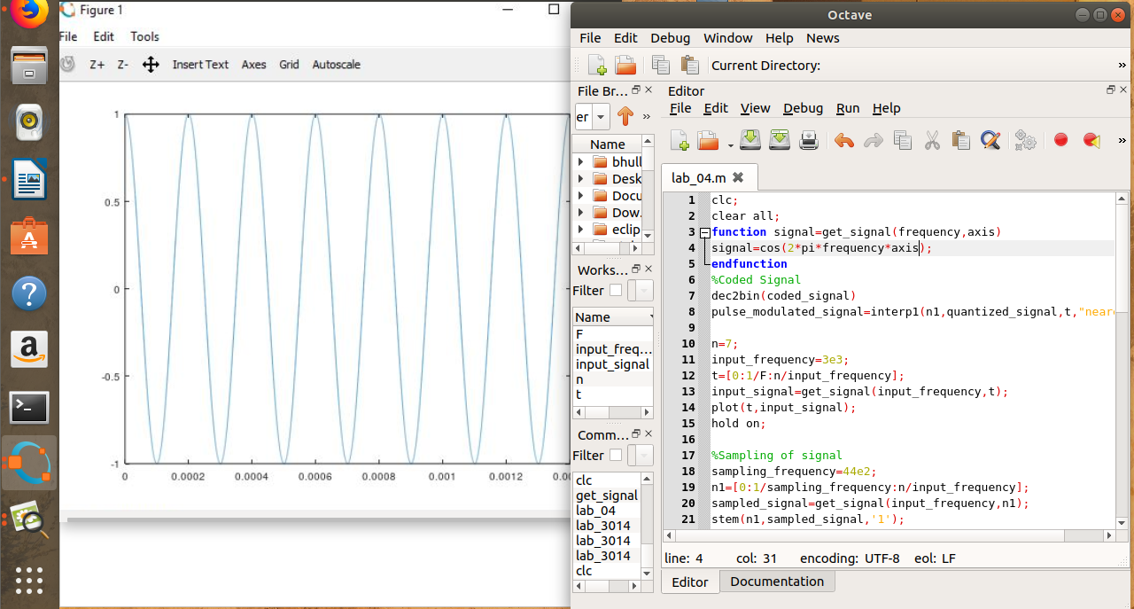

**2. Encoded binary Signal**

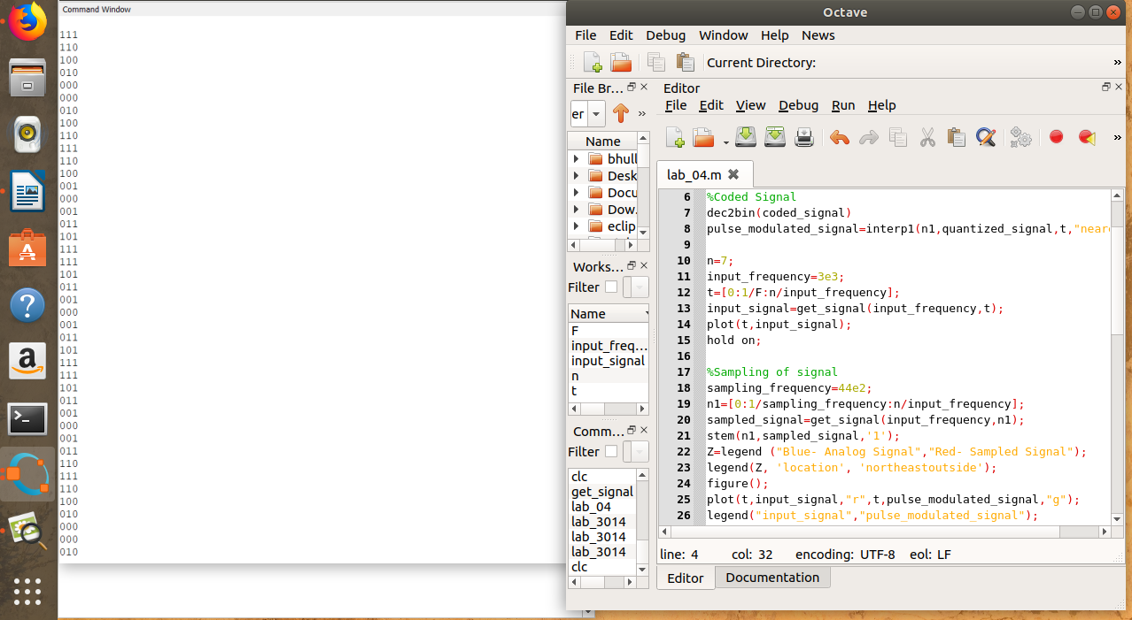**3. Sampling**

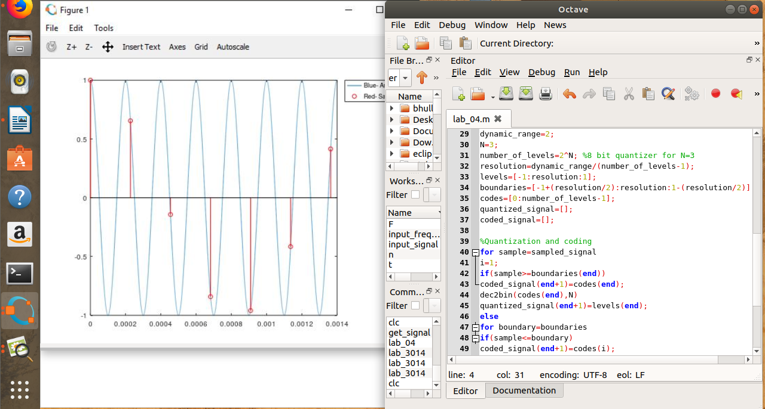

**4. Quantized Signal**

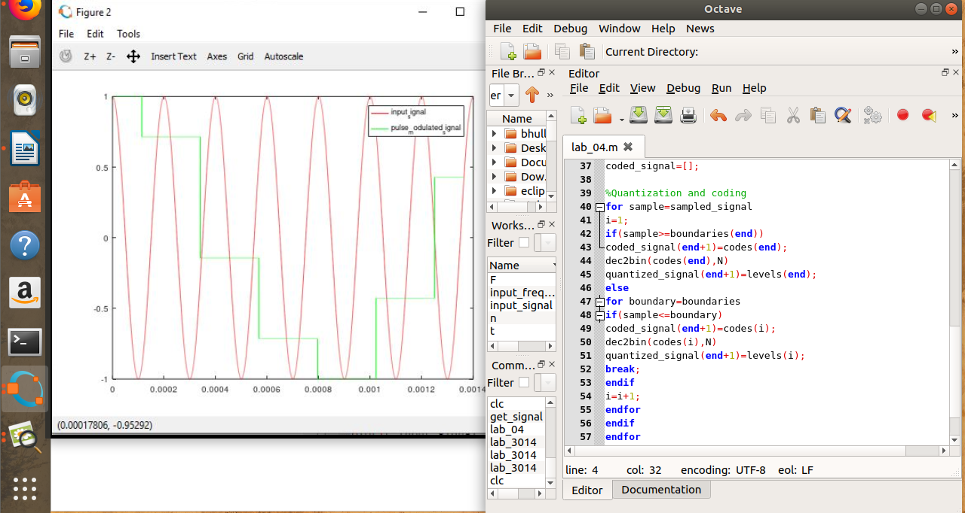

**5.Bipolar Return to zero(BRZ)**

